# 

EECS 725

**Detection of Areas of Basal Melt from RES Data**

Manjish Adhikari (2870257)

**Abstract:**

Study of ice dynamics play a crucial role in predicting the future climate change. Subglacial water makes the ice sheet unstable leading to breakage of ice sheets. Detection of the areas of basal melt helps in predicting the stability of certain outlet glacier or ice sheet and take certain preventive measures. The radar used to map the thickness of ice sheet can also be used to know the basal conditions. The higher bed reflectivity after compensating for losses is directly related to basal melt and thus can be used to find the locations of basal melt and subglacial lakes. The method is employed to Greenland ice sheet to detect the areas with basal melt. Validations are made studying the geophysical conditions of the bed as well.

Table of Contents

Introduction 3

Radar 4

MCoRDS 2 Specifications: 4

Analysis of MCoRDS 2 Radar: 4

Range Resolution: 4

Range Accuracy: 5

Along Track Resolution 5

Data Rate 5

Data Processing 6

Methodologies 6

Corrections for Bed Power 7

Result and Findings 9

Conclusion 12

References 13

## Introduction

With the global climate change and temperature rise there’s constant effect on the polar ice sheet thus making significant change in the rise of sea level. Huge efforts have been made to study the ice sheet conditions especially the Antarctic and Greenland ice sheet which can bring about a significant change in the sea level rise. Scientists have been constantly monitoring these ice sheets and studying the ice sheet conditions. Several models have been proposed to explain the ice sheet conditions and are constantly used to explain the ice conditions. Ice sheet dynamics play important role in explaining the glaciers and melting. Ice motion is affected by two main factors i.e. temperature and the strength of the bases. A lot of ice breaks due to the melting of ice sheets both superficially as well as the basal melting. The ice slides due to basal melt which is caused by high pressure from thick ice sheet. The melting point of water decreases with the increase in pressure thus thicker glacier are likely to cause basal melt as well as they also provide thermal insulation meaning higher temperature favorable for melting. Ice sheet loss is then caused due to sliding of ice sheets into the oceans. So studying the basal conditions of these ice sheets play a crucial role in accessing the climate change.

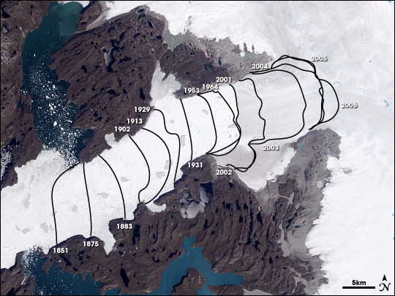

Figure 1. Jakobshavn Glacier

Figure 1 shows the retreat of Jacobshavn glacier in Greenland which is retreating inland at a very high rate directly indicating the alarming rate at which the melting of ice sheets is occurring.

## Radar

Center for Remote Sensing of Ice sheets deployed MCoRDS 2, a nadir looking radar mounted on an aircraft like P3 flying usually at the height of 480 meters from the ice surface to map the thickness of the ice sheet over Greenland and Antarctica under NASA’s Operation Ice Bridge (OIB). This analysis uses the north western part of Greenland which was mapped using MCORDS2 in 2012.

## MCoRDS 2 Specifications:

|  |  |
| --- | --- |
| Center Frequency | 195 MHz |
| Bandwidth | 180-210 MHz |
| Transmit Signal Type | Linear Up Chirp |
| Transmit Power | 1050 W |
| Signal Duration | 1 µs and 10 µs (Low Altitude) 30 µs (High Altitude |
| Transmit Channels | 7 |
| Receive Channels | 16 |
| Noise Figure | 2 |
| Sampling Rate | 111 MHz |
| ADC Bits | 14 |
| Dynamic Range | Waveform Playlist |
| Rx Aperture | Three (2 wavelength, 3.5 wavelength, and 2 wavelength ) apertures, baseline of 6.4 m between each aperture |
| Tx Aperture | 3.5 wavelength aperture; fully programmable |
| Mode | Mixed monostatic and bistatic tx/rx |
| Data Rate | 32 MB/s per channel |

## Analysis of MCoRDS 2 Radar:

### Range Resolution:

Since the center frequency of the radar is 195 MHz and the bandwidth of the radar is 210-195= 30 MHz the wavelength of the signal in ice can be calculated at the center frequency as:

$$λ=\frac{c}{f×\sqrt{3.15}}=\frac{3×{10}^{8}}{195e6×\sqrt{3.15} }=1.54 m$$

Similarly range resolution can be calculated as:

$$∆R=\frac{c'}{2B}=\frac{3×{10}^{8}}{2×30×10e6×\sqrt{3.14} }=2.817m$$

However the use of window widening factor of 0.88 for no windowing and 1.53 for 20% Tukey time domain window changes the range resolution as:

$$∆R=k_{t}×∆R=0.88×2.817=2.5 m (No Windowing)$$

$$∆R=k_{t}×∆R=1.53×2.817=4.31 m (Windowing)$$

### Range Accuracy:

The range accuracy for the given radar can be calculated from the given relation:



To detect the targets that are separated by SNR of at least 20 dB the range accuracy for the radar is given by



### Along Track Resolution

The along track resolution depends on the type of processing used on the data products. For this radar, the SAR processed image is specified to have synthetic beamwidth of 10 degrees so we can calculate the along track resolution as:



Where = 1.1 is the specified along track window widening factor for 20% Tukey window.

### Data Rate



$$Data rate=12000×30×{10}^{-6}×111×{10}^{6}×14=559.44 Mbits=69.93 MB/s per channel for 30 us pulse duration$$

This is the data rate without any coherent integrations and after coherent integration is applied to it, data rate further reduces the data rate by $N_{coh}.$

## Data Processing

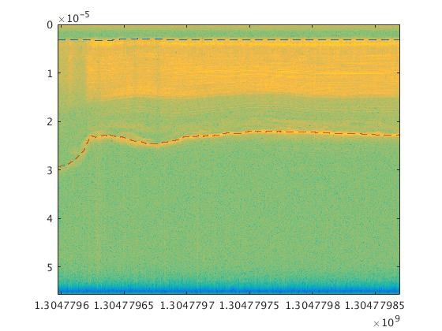 The radar received data employs advanced data processing and thus the results can be viewed in real time by quick look. The data are saved in the form of radar echograms which contains several information about received power, GPS time, latitude, longitude, elevation, echo return time and so on. The echogram can be traced for the ice surface and ice bed using different trackers and algorithms. Figure 2 shows a radar echogram.

Figure 2 Radar Echogram

Here we can see the ice surface marked with blue dotted line and ice bed with red dotted line so we can derive a lot of information from the echogram such as the thickness of ice, the bed topography, bed reflected power and so on.

## Methodologies

The signal received by the radar receiver can be estimated using the radar range equation.



This equation can help us analyze the properties of the target but several factors of losses ‘L’ needs to be compensated before coming into the conclusion.

The radar backscattered echo strength varies when reflected from different types of interfaces because of its dielectric values and nature of the surface. Reflectivity is related to reflected power that is received by the radar receiver.









As we can see the reflectivity of ice water interface is pretty high when compared to ice rock interface so we can expect higher received power from the ice water interface and lower from ice rock interface thus this property can be analyzed from the bed echo strength to make distinction between frozen bed and basal melt.

However there are also certain loss factors that needs to be compensated first before looking at the ice bed echo strength. When radar signal moves through the ice then there is attenuation of signal and based on the depth of the bed, type of the ice and its constituents, roughness of the interface and so on, hence this needs to be compensated first before getting the final bed reflectivity.

When signal propagates through the ice, the bed echo strength is given by the equation

$${[P]}_{dB}={[S]}_{dB}-{[G]}_{dB}+ {[R]}_{dB}- {\left[L\right]}_{dB}$$

where Bed echo strength (P) is function of radar system parameters(S), geometric spreading loss(G), bed reflectivity(R), englacial attenuation (L). So we need to calculate the reflectivity ‘R’ of the bed compensating all the other parameters from the bed echo strength ‘P’.

### Corrections for Bed Power

#### Interference and Fading:

To remove the effects of interference the received signal is coherently averaged over a distance of 4 meters so that the signal variance is also reduced. Based on the type of the interface the received signal also varies i.e. when the surface is smooth a very high abrupt signal is received whereas from rough surfaces a less abrupt signals are received.

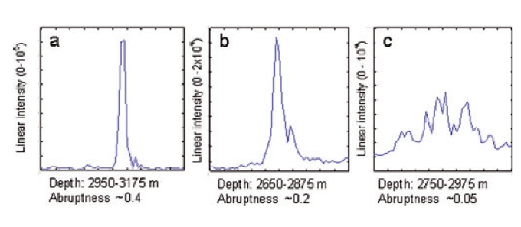

Figure 3. High Abrupt , Abrupt and less abrupt signals from flat and rough surfaces [1]

Primary Illuminated Area: The area illuminated by the radar and that is primarily responsible for the reflection is given by

$$R_{p}=\sqrt{\frac{D×p}{\sqrt{ε_{ice}}}}$$

Where $R_{p}$ is the radius of the interface, $p=4.99$ is the radar pulse half width, and $D$ is the depth of ice. For a depth of $3000m$ it is calculated to be $R_{p}=92 m$,and thus Diameter= 184 m which is the interface length responsible for the primary reflection. The received energy over the basal reflection envelope is aggregated and abruptive index and signal power is calculated.

Abruptive Index: The abruptness of the signal is defined as the sudden change in the power value and is calculated as:

$$I_{abr}=\frac{P_{peak}}{P_{ag}(x)}=\frac{{({\left\{p\right\}}_{X})}_{peak}}{{\{\sum{D_{int}P\}}}_{X}}$$

Where $P_{peak}$ is the bed power and $P_{ag}\left(x\right)$ is the aggregate power over the echo envelope ‘ $D_{int}'$ which is the depth bins and is given a threshold of 5% of the peak power. It’s value lies usually between 0.05 and 0.5. A threshold value of abruptive index is put upon the interface that is flat at the scale of ice depth.

#### Geometric Spreading Loss

When the signal is radiated from the antenna then the power of the signal is continuously reduced when it travels away from the antenna. The geometric loss at ice depth $‘D’$ when radiated from an antenna with gain $‘g’$ radiating signal of wavelength ‘ $λ'$ at the height of $‘s’$ is given by

$$G=20 \log_{10}( \frac{gλ}{8π\left(s+\frac{D}{\sqrt{ε_{ice}}}\right)})$$

where the antenna gain $g=4$ and $λ=1.54m$ for the given radar.

#### Englacial Attenuation

When signal travels through the ice medium then the signal is continuously attenuated so the received power of the backscatter from the bed is reduced. Based on the nature of the constituents of ice the attenuation provided differs and is variable from region to region. However for Greenland, it is empirically calculated as

$$B=2.3×\frac{3000}{H+2000} (dB per 100m)$$

So when these corrections are made the reflectivity of the bed power can be calculated correctly and looked into for analysis.

Interface Smoothness

If there is water at the bed then due to pressure gradient it forms a flat surface hence only the areas with flatter surfaces and high reflectivity are representative of basal melt.

To measure the interface smoothness the coherence index of the bed needs to be calculated which is given by

$$I_{CO}=\frac{\int_{D_{int}}{<|\int_{X_{int}}{|{ψ\left(D,x\right)dx|}^{2}>dD}}}{\int_{D_{int}}{\int_{X_{int}}{{|ψ(D,x|}^{2}}}dxdD}$$

where D is the ice depth, x is the along track distance and $X_{int}$ is the along track interval for both coherent and incoherent integrations and $D_{int}$ is the aggregation interval of the basal echo envelope.

However, this requires the slope correction before calculating the coherence index. Higher values indicate flat surfaces since integrations over $\sim$ 200m is done, $I_{CO}>0.3$ indicate flat interfaces within $\sim 0.2 m$ So the areas that are sufficiently flat, have higher abruptive index and reflectivity are the areas with basal melt. However there may be areas with high reflectivity but low abruptness which could be due to rough surfaces and thus not representative of basal melt. Cases also exist where surface is smooth with high abruptness but reflectivity values fall down which may be due to aircraft turns. However this method can detect a number of areas with possible basal thaw.

## Result and Findings

The above described method was employed to the Cape Alexander area of Greenland and the resultant reflectivity was calculated. The area with particularly high values of the reflectivity, abruptness and coherence index are analyzed and a subglacial lake was detected at the particular location which is presented below.

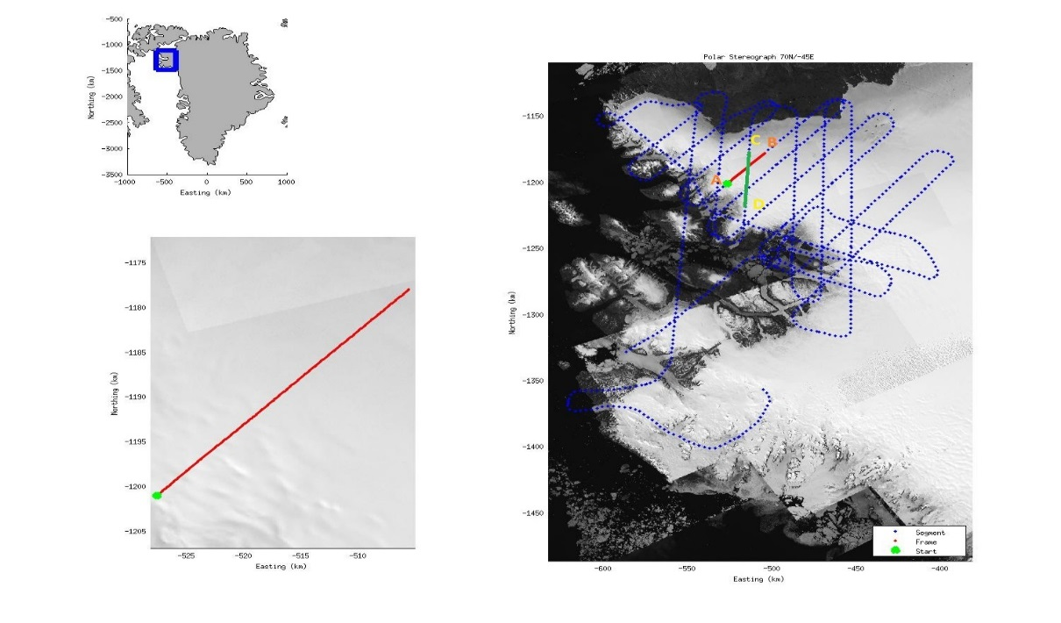

Figure 4. Flight Lines

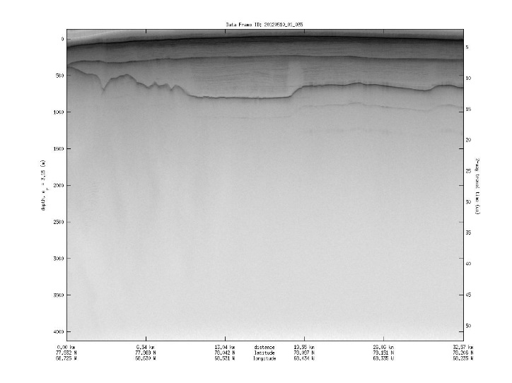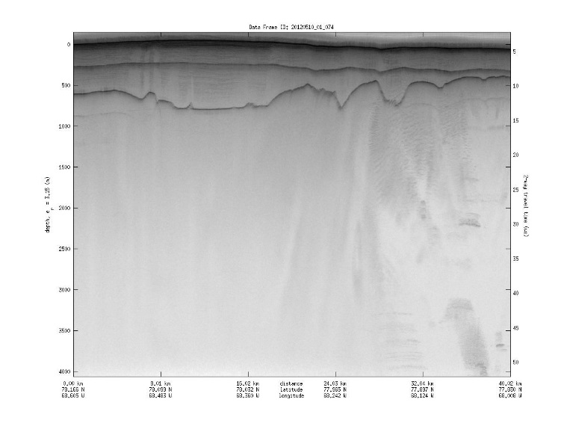

Figure 6 Echogram 20120510_01_035

Figure 5 Echogram 20120510_01_074

*Figure 7. Depth, Reflectivity, Coherence Index and Abruptive index for the two flight lines*

The particular location as shown in figure no. 7 was of particular interest because the reflectivity values, abruptive index and coherence index were high at those locations. When the interface was studied from the echogram the location had pretty flat interface thus the presence of subglacial lake. So a subglacial lake was detected at that particular location using this method which is validated by Palmer in [5]. So this method can detect the basal melt properly and was further used at other locations to generate the map of basal thaw based on the criteria that the signal power is greater than 0 dB and also the coherence index greater than 0.3, abruptness greater than 0.3.

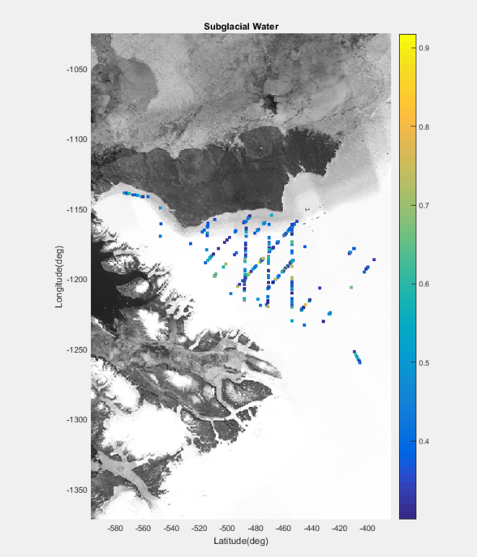

Figure 8 Possible Areas of basal melt

Figure 8 shows the possible areas of basal melt. One of the locations consist a sub glacial lake which was determined by Palmer before, hence following the same method these other areas have also basal melts however they don’t contain subglacial lakes and just have intermittent basal melts.

## 

## Conclusion

Thus it is possible to detect the areas of basal melt using the radar measurements. The basal conditions analysis using from the radar can help for easy analysis without the need to drill boreholes and study the area. This method can be extended for the ice sheet study. The uncertainty about this method is the englacial attenuation calculation which assumes uniform attenuation rate in ice which is not true. Better compensation of the englacial attenuation can result in better performance of this method.

## References

[1]. Oswald, and Gogineni, Recovery of subglacial water extent from Greenland radar survey data, Journal of Glaciology, Vol. 54, No. 184, 2008

[2]. Leuschen, Carl, Prasad Gogineni, Richard Hale, John Paden, Fernando Rodriguez, Ben Panzer, Daniel Gomez. 2014, updated 2016. *IceBridge MCoRDS L1B Geolocated Radar Echo Strength Profiles, Version 2*,

[3]. Oswald, and Gogineni, Mapping Basal Melt Under the Northern Greenland Ice Sheet, IEEE Transactions On Geoscience And Remote Sensing, Vol. 50, No. 2, February 2012

[4]. Center for Remote Sensing of Ice sheets (CReSIS) at *data.cresis.ku.edu/data/rds/rds_readme.pdf*

[5]. Palmer, S. J., J. A. Dowdeswell, P. Christoffersen, D. A. Young, D. D. Blankenship, J. S. Greenbaum, T. Benham, J. Bamber, and M. J. Siegert (2013), Greenland subglacial lakes detected by radar, Geophys. Res. Lett., 40, 6154–6159, doi:10.1002/2013GL058383.

[6]. T. M. Jordan,J. L. Bamber, C. N. Williams, J. D. Paden, M. J. Siegert, P. Huybrechts, O. Gagliardini, and F. Gillet-Chaulet,An ice-sheet-wide framework for englacial attenuation from ice-penetrating radar data

[7]. C. Allen, Radar Measurements, EECS 725 presentation slide